Report 7 Structure Draft v2

**Topic:**

**Why is it important/essential 1.5 degree?**

**"is it possible for the world to reach 1.5 degree in future?"**

TAG: Climate change, Low Carbon

**Structure**

* Intro/Background [Question?]
* Data
* Analysis and Projection
* Cases and Solutions/Call to actions (gov, org, indiv)
* Conclusion (answer the question)

1. Introduction:

* Brand new start: we need to define again about the climate change and harm of CO2 gases.
* CO2 emission data (from the 20th century 1900 – 2020) in billion tons. <https://www.iea.org/reports/global-energy-review-2020/global-energy-and-co2-emissions-in-2020> (1900-2020 data)
* Question: Is it possible for us to reach the future 1.5 degree?

1. Analyse the data

* The drop of some part is given by reason, but today we are going to analyse the biggest drop which occurred in 2019-2020.
* Turns out there is research about “Temporary reduction in daily global CO2 emissions during the COVID-19 forced confinement”, <https://www.nature.com/articles/s41558-020-0797-x> will use this as the source, data and proven analysis. (As simple as possible to understand)
* Turns out their result showed there is relationship covid 19 to the low carbon emission relationship, proved by IEA as well, **the lockdown has affect the demand for the global energy in the first quarter of 2020, less transportation used, 8% decline in emissions from coal, 4.5% from oil and 2.3% from natural gas.**
* All of these are great news, but what will happen if there is no lockdown, IEA also projected similar percentage drop with the research projection.

1. World declaration for 2050 carbon neutrality and others declaration. 1.5degree C and 2 degree C scenario.

Ipcc, 2018 - <https://www.ipcc.ch/sr15/>

1. Future greenhouse gas emission and warming scenario.（Projection）

<https://folk.universitetetioslo.no/roberan/t/global_mitigation_curves.shtml>

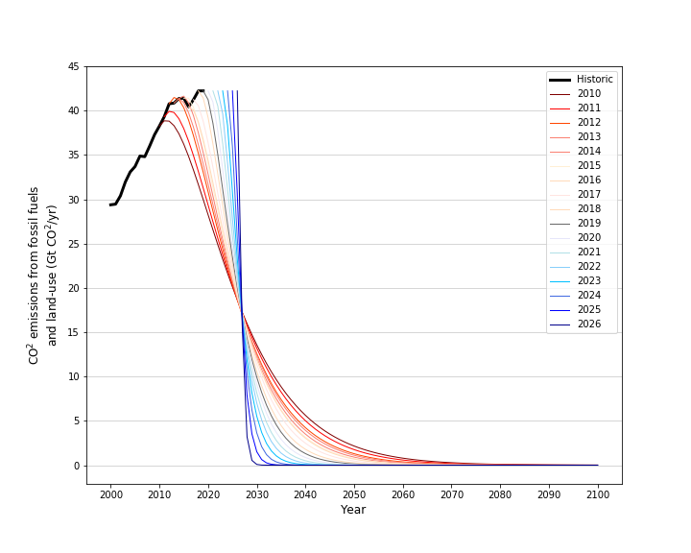

1.5-degree scenario projection

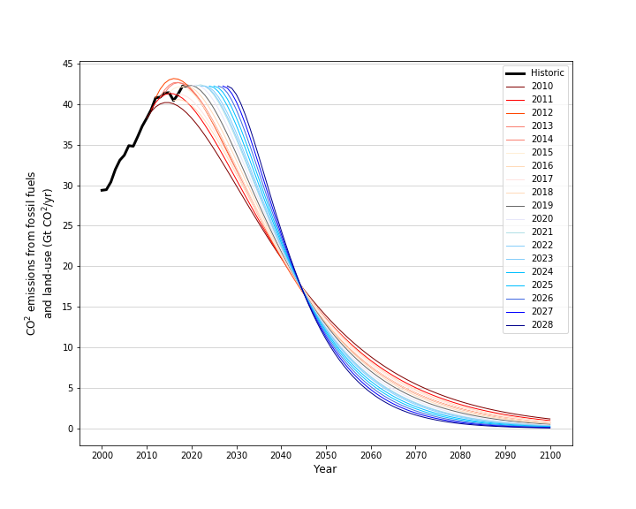

2-degree scenario projection

<https://essd.copernicus.org/articles/10/2141/2018/essd-10-2141-2018.pdf>

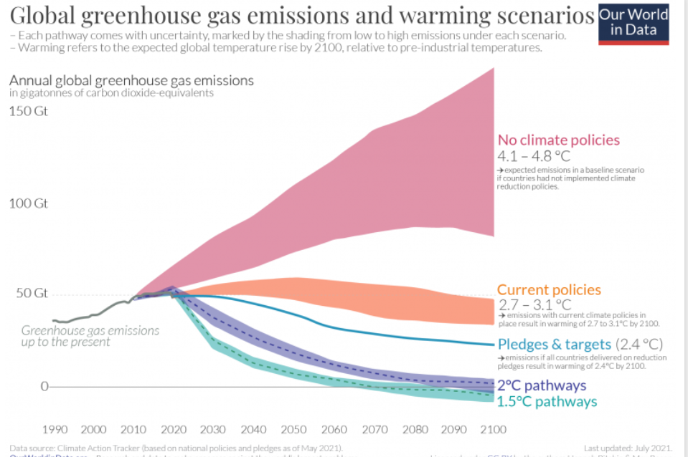

* Despite we have policies it still hard to reach the target.
* We need to do more decarbonisation or things to tackle climate change, such as reduce emissions by replace the fossil fuel to renewable energy, improve and promote more of CCUS technology which has negative carbon emission solution and carbon trading.

Gov/policy

International: COP26

China: 30·60

......

Organisation Case: SEE Conservation

COP25 | 阿拉善SEE展示应对气候变化成果，推动跨界合作

“绿链行动” 绿色供应链

<https://www.163.com/dy/article/F0IEOUGN0512MPDJ.html>

Nature-based solution: Env protection

* As commoners, we can do some movement such as reduce waste, use more organic product, help and promote the upcycling or recycling company by sorting the waste. Could help to achieve the target, since reduced the ghg emission on the atmosphere.

Individual Case: Ant Forrest

中科院发布蚂蚁森林GEP核算报告 5亿中国人种出超百亿生态效益

<https://finance.sina.com.cn/tech/2021-03-10/doc-ikkntiak7275695.shtml>

* More context about the 1.5 degree pathways target and how to achieve it.

1. Conclusion (which better like the last report or the formal conclusion)

[Answer the question]